Deep Learning on Hardware Accelerators

236781

Final Project - Deep Image Prior

Submitted by:

|  |  |  |
| --- | --- | --- |
| Aviv Caspi | 311136691 | avivcaspi@campus.technion.ac.il |
| Roi Tzur-Hilleli | 207717414 | roith@campus.technion.ac.il |

Abstract

Deep Learning methods have been used extensively in order to solve standard inverse problems in the area of image processing such as restoration, denoising, super-resolution, and inpainting. Such methods primarily use deep convolutional networks to extract visual features through learning their parameters, which lead to state-of-the-art results in those problems.

The conventional training of such networks is using very large datasets, which allows the network to learn the visual features of images, required for the specific task. Our work is based on a paper, which shows that even before any such training, the parameters of a generator network are able to capture many low-level image details.

In addition, we tried to expand on the proposed method and considered optimizing the noise-input as well, and also learning a loss function through adversarial training. Then we compared the paper’s results to our’s, in terms of convergence time, and quality of the result. We found out that optimizing the input noise leads to much faster convergence time, and for some tasks even better quality results. However, the adversarial training produced noisy results that are worse than previous methods.

Intro

Our project is based on the article “Deep Image Prior” [1], which shows that deep generator convolutional neural networks can produce excellent solutions to standard inverse problems in the area of image processing, without any prior of the images or the problem.

The inverse problems that were discussed in the original paper, and that we worked on as well are the following:

* Denoising
* Restoration
* Inpainting
* Super-resolution

These problems have been tackled by many deep learning models and methods. The current state-of-the-art solutions use deep convolutional neural networks, trained on large datasets of images. One may thus assume that their excellent performance is due to their ability to learn realistic image priors from data In the paper, the authors have shown that, contrary to the belief that learning is necessary for creating good image priors, a lot of image statistics are captured by the structure of the convolutional image generator, independent of learning.

In contrast, the method proposed in the article does not use any data other than the degraded image and the generator network. The training uses gradient descent to make the generator produce the degraded image from random noise. However, before the network overfits and produces a degraded image, it produces relatively clean images, that are comparable with other supervised learning-based methods.

In order to show this, the authors (and us when we reproduced the results of the paper) have built a deep ConvNet (as a generator network) and instead of training the network on a large dataset of degraded-clean image pairs, they fitted the network on a single degraded image (for each problem). This shows that the only information required to solve this kind of problem is contained within the single degraded input image and the structure of the network.

In this scheme, the network weights serve as a parametrization of the restored image. The weights are randomly initialized and fitted to maximize their likelihood given a specific degraded image and a task-dependent observation model.

This means we search for the optimal restored image parameters in the space of the neural networks’s parameters.

In our work, we tried to take a different approach of training the network. Instead of searching only in the space of the neural networks’ parameters, we optimized the solution by searching in the input image space as well (which means that while we fit the network to a specific image, we also find the optimal input to the network, instead of fixing it like they do in the paper). Another approach we took was learning the optimal loss function for each application using adversarial training, which uses a discriminator to train the generator, instead of a regular MSE loss function.

The criteria on which we compared all of the methods, are the number of gradient descent iterations required to reach the clean image (convergence time), and the quality of the produced clean image. Ideally we would like the training time to be low, and the quality of the generated image to be high (similar to the ground truth).

Methods

TODO : explain each application and show an example of the input - target - result  
also write the formulas of the minimization target

Implementation and Experiments

We will start by specifying which parts were implemented by us and which were taken from the implementation of the original paper:

Models architecture, input generation, networks training, adversarial network and training, results representation, experiments code - Implemented completely by us.

Notebooks - Implemented by us, using the paper implementation as template for notebook structure.

Utils such as image loading, cropping, conversion et centra - Were taken from original paper code.

**Implementation**:

In all of the applications we use Unet as the generator network.

It's structure as described in the paper:

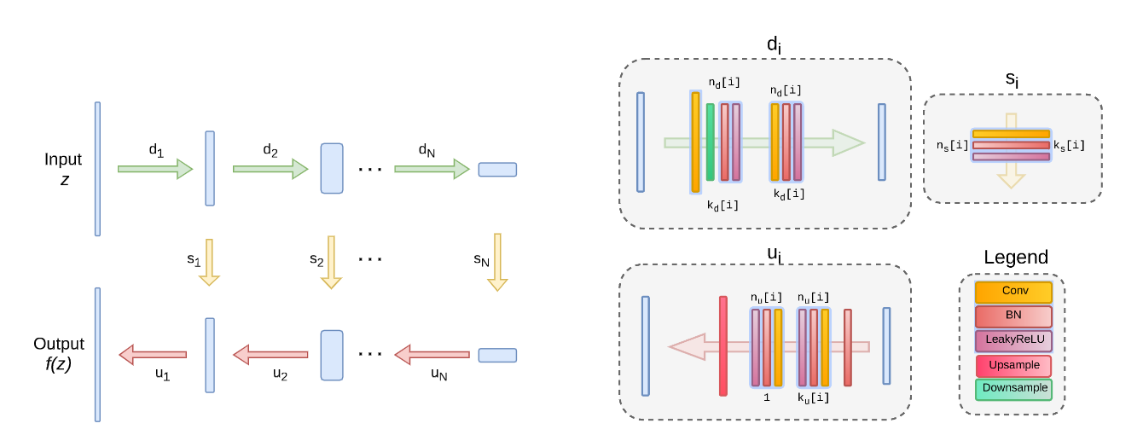

In some applications we added the skip connections and in some we removed them. Also the dimensions of each layer varies between each image and problem.

Discriminator architecture:

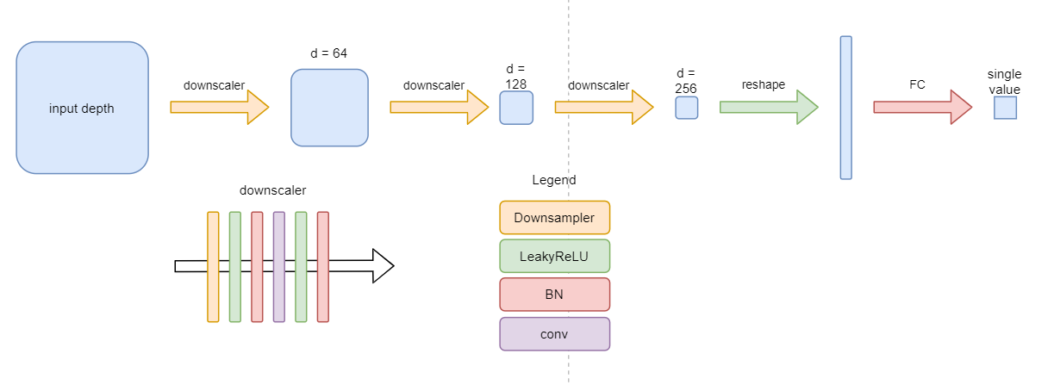

In all the applications the discriminator structure is similar, but trained using different hyperparameters.

**Structures and Hyperparameters for each application:**

(We will show one architecture and HP for each application, the notebooks have the architecture and HP for other images we trained on)

n - number of filters for each layer (up/down/skip)

k - kernel sizes for each layer (up/down/skip)

regular training: using MSE as loss function

adversarial training: using Discriminator for training generator

**Restoration**: (Kate image)

$z ϵ R^{32xWxH }∼U(0, 0.1)$ $n_{u}=n_{d}=[16, 32, 64, 128, 128]$ $k_{u}=k_{d}=[3, 3, 3, 3, 3]$ $n_{s}=[0, 0, 0, 0, 0]$ (no skip) $k_{s}=[1, 1, 1, 1, 1]$

Regular training :

LR = 0.01  
num_iter = 1000

Adversarial training:

dsc_lr = 0.0001  
gen_lr = 0.001  
num_iter = 4600  
Label Noise = 0.2  
weight_decay = 0.005

**Inpainting**: (Vase image)

$z ϵ R^{2xWxH }∼Meshgrid$ $n_{u}=n_{d}=[128, 128, 128, 128, 128]$ $k_{u}=k_{d}=[3, 3, 3, 3, 3]$ $n_{s}=[0, 0, 0, 0, 0]$ (no skip) $k_{s}=[1, 1, 1, 1, 1]$

Regular training :

LR = 0.01  
num_iter = 5000

Adversarial training:

dsc_lr = 0.0001  
gen_lr = 0.001  
num_iter = 7000  
Label Noise = 0.2  
weight_decay = 0.005

**Super-resolution**: (Zebra factor 4 image)

$z ϵ R^{32xWxH }∼U(0,0.1)$ $n_{u}=n_{d}=[128, 128, 128, 128, 128]$ $k_{u}=k_{d}=[3, 3, 3, 3, 3]$ $n_{s}=[4, 4, 4, 4, 4]$ $k_{s}=[1, 1, 1, 1, 1]$

Regular training :

LR = 0.01  
num_iter = 2000

Adversarial training:

dsc_lr = 0.001  
gen_lr = 0.001  
num_iter = 1800  
Label Noise = 0.0  
weight_decay = 0.00

**Denoising**: (Jet image)

$z ϵ R^{3xWxH }∼U(0,0.1)$ $n_{u}=n_{d}=[128, 128, 128, 128, 128]$ $k_{u}=k_{d}=[3, 3, 3, 3, 3]$ $n_{s}=[4, 4, 4, 4, 4]$ $k_{s}=[1, 1, 1, 1, 1]$

Regular training :

LR = 0.01  
num_iter = 2400

Adversarial training:

dsc_lr = 0.001  
gen_lr = 0.005  
num_iter = 8000  
Label Noise = 0.2  
weight_decay = 0.05

All training used ADAM optimizer.

**Loss formulations**:

Regular training:  
For the regular training we used MSE loss function for all the applications -

Lets define some variables to work with: $x_{0 }- Original uncorrupted image$ $m-Mask used for restoration/inpainting ϵ\{0,1\}^{HxW}$ $z -Input of the network - usually random noise$ $f_{t}() -Our generator network (t - network parameters)$ $d() - Downsampler function for Super-Resolution$

Our loss function in case of **restoration and inpainting**: $Loss(f_{t}(z)) =||f_{t}(z)⋅m-x_{0}⋅m{||}^{2}$

**denoising: $Loss(f_{t}(z)) =||f_{t}(z)-x_{0}||^{2}$**

**Super-Resolution: $Loss(f_{t}(z)) =||{d(f}_{t}(z))-{d(x}_{0})||^{2}$**

Adversarial training:  
For the adversarial training we used BCE loss function to train the dsc and gen:

$g() - Our Discriminator$

**discriminator loss: $Loss = BCE(1, g(x_{0})) + BCE(0,g(f_{t}(z)))$**

**generator loss: $Loss = BCE(1, g(f_{t}(z)))$**

Explanation:  
The discriminator will try to identify which images are real and which are created by the generator. While the generator will try to “trick” the discriminator to think the generator images are the real ones.

**Experiments**

Evaluation metrics: PSNR - Peak Signal to Noise Ratio.  
We compared each result using the output of the network minus the original image (before mask/noise added) PSNR.(e.g. for restoration: we use PSNR of $f_{t}(z)-x_{0}$)  
Also we used masked output minus the corrupted original image PSNR (we called it noisy_psnr/masked_psnr).(e.g. for restoration: we use PSNR of $f_{t}(z)⋅m-x_{0}⋅m$)  
Those metrics can help us see how good was the reconstruction of the original image, and also help us see the progress of our learning.

We ran a lot of experiments on each of the problem we faced:  
1. First of all **Reproducing paper result:**

The first experiment we did was checking our implementation and network can achieve the same results as the paper implementation did.  
We configured our network, hp, loss function and input to be the same as stated in the paper and ran the experiment.

2. **Optimizing over the input image**:

Second experiment we did was checking how we should optimize the training to get the optimal input image.

1. We configured our network to optimize both the network parameters and the input image.
2. We configured our network to first optimize the network parameters and after finishing training, we optimized the input image on the trained network.

The goals of those experiments were, first of all, to check if optimizing on the input image can achieve better results than optimizing only on the network parameters (as the paper implementation did).  
Second of all we wanted to check if it is better to optimize the input while or after training the network.

3. **Adversarial training**:

Third experiment we did was finding the best configuration for the adversarial training.

1. Checking if our adversarial model is training on each application and image.
2. Finding the best discriminator architecture for each application and image.
3. Finding the best hp for each application and image.

For each experiment we had to check the configuration for all applications and images, and tweak the network and hp to achieve best results for all the images.   
One of our goals was to see if adversarial training can achieve better results (pnsr wise) than regular training.

4. **Adversarial + Input optimization**:

Lastly we tried to combine the adversarial training with input optimization.  
Our goals were to check if we can achieve even better results, by combining the methods.

Results

In this part we will show the results of the experiments we described in the previous section.  
We will show image results and graphs of some of the experiments(due to a large number of experiments), all other data regarding the results will be in the results excel file and report directory.

1. Let's start with the first experiment of reproducing the results of the original paper:

**Restoration**:  
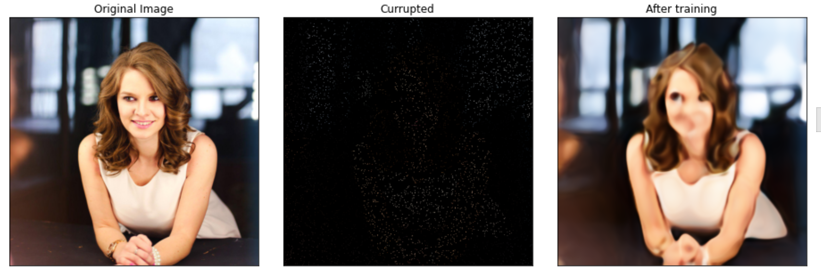Figure 1: **Restoration of an image from only 2% of original pixels.**Left - original image before any changes, Middle - the corrupted image (2% of original pixels) and also the target image for training, Right - reconstructed image after regular training.  
pnsr = 24.75  
psnr_masked = 48.44

**Inpainting:  
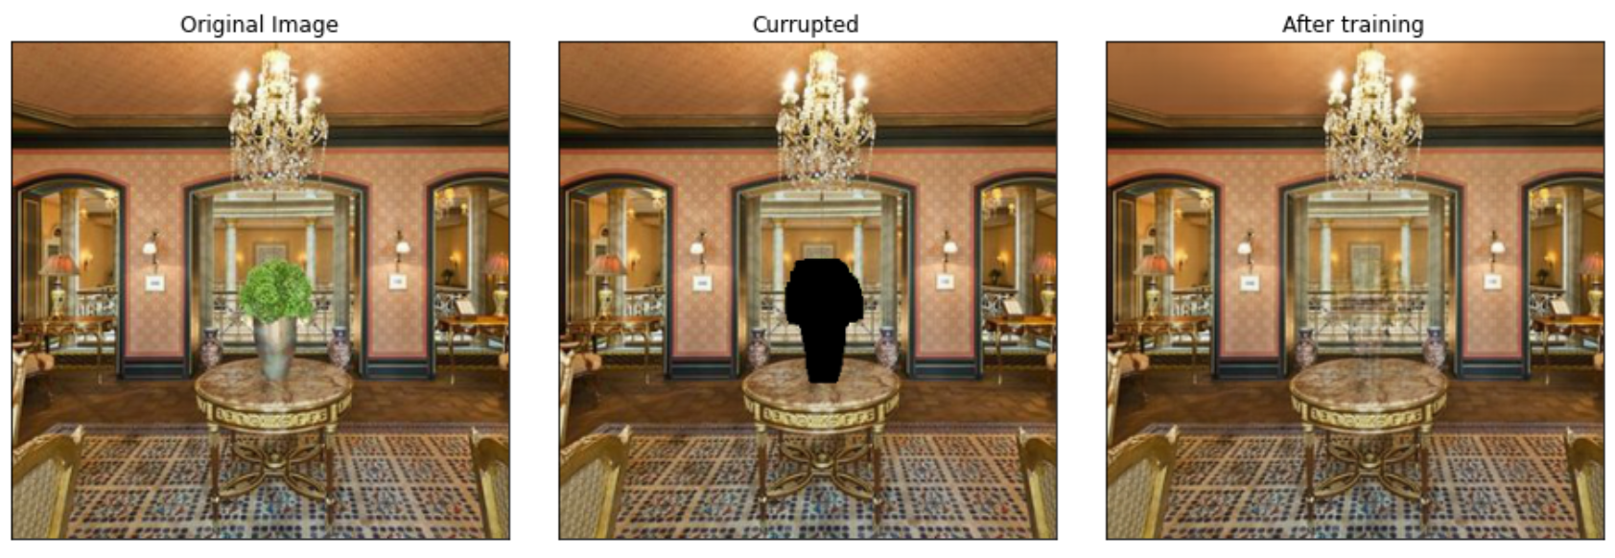**Figure 2: **Reconstruction of an image with a big hole in the middle.**Left - original image before any changes, Middle - the corrupted image (vase was masked) and also the target image for training, Right - reconstructed image after regular training.  
pnsr = 29.22  
psnr_masked = 35.99

**Super-Resolution**:  
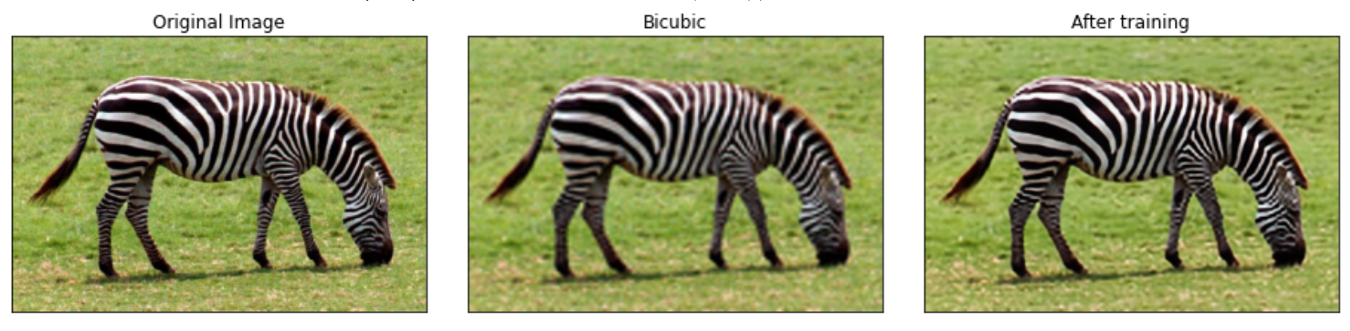  
Figure 3: **Super-resolution of low resolution image - factor 4.**  
Left - original image before any changes, Middle - the low resolution image (used bicubic downsampling) and also the target image for training, Right - reconstructed image after regular training.  
pnsr = 24.03  
psnr_downsampled = 32.83

**Denoising:**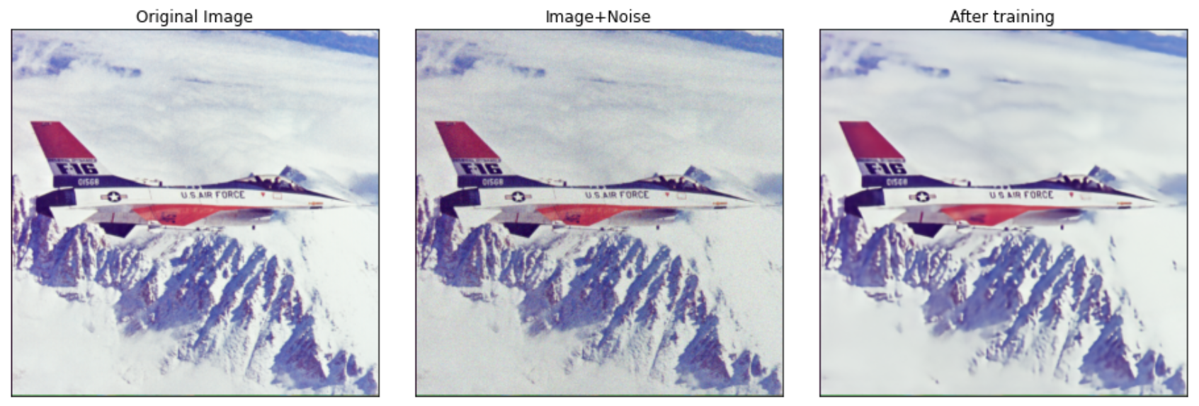  
Figure 4: **Removing normal noise from an image.**  
Left - original image before any changes, Middle - the original image + normal noise and also the target image for training, Right - reconstructed image without noise after regular training.  
pnsr = 31.6  
psnr_noisy = 27.54

As we can see in figures 1-4, we have achieved the same result as stated in the paper with our implementation.

1. The second part of the experiment was to test input optimization and see if it improves the result (in terms of speed and image quality).

We will show a number of experiments results which we think are important to examine our work.

**Inpainting:  
a.** Vase:  
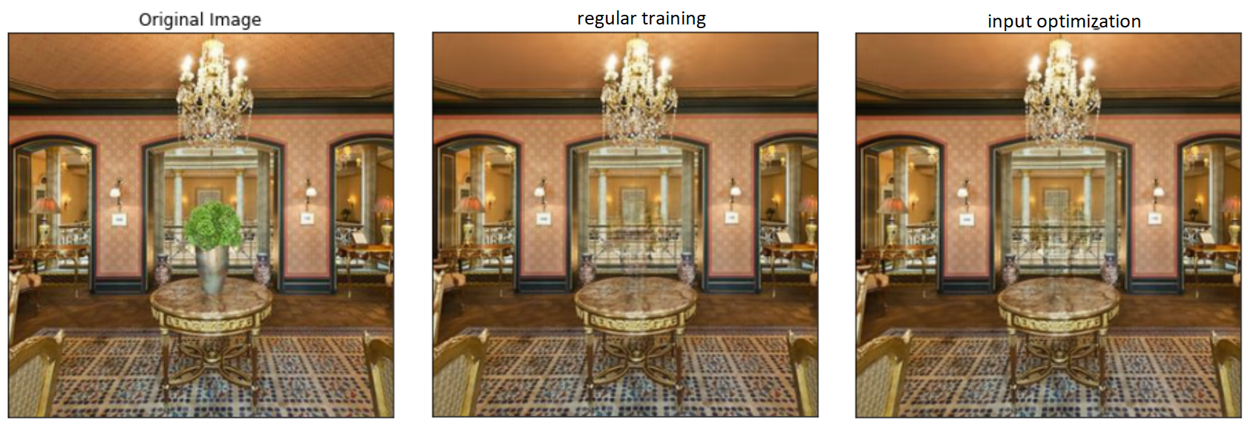Figure 5: **Comparing regular training to input optimization of vase image.**We can see that the image we got after optimizing over the input as well as over the network parameters has a bit better details (as can be seen by the ceiling pattern).  
As to psnr comparison:  
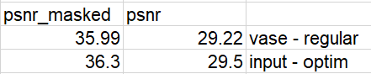  
We got a slight better result in terms of psnr.  
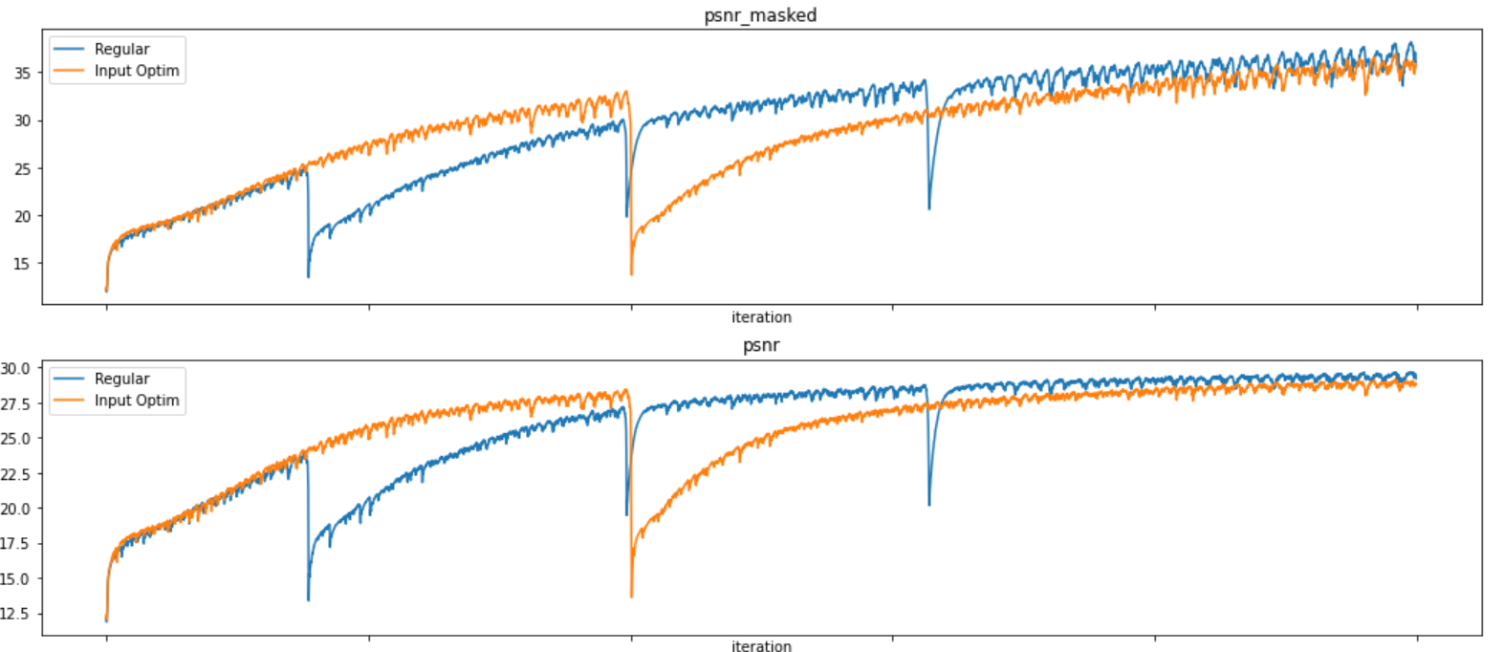  
Figure 6: **PSNR graphs of vase regular vs input optimization training.**We can see a good comparison between the training methods.  
The first thing we notice is that input optimization training was able to achieve better psnr in less than half the iterations number it took the regular training.  
(regular - 6000 iterations, input optim - 2500 iterations)  
Other than that we notice that there was no other big difference between the results.

**b. Kate:**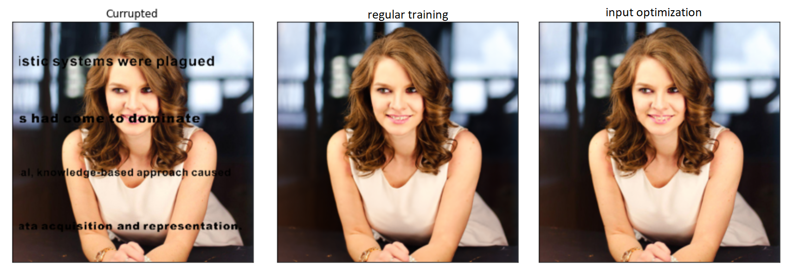  
Figure 7: **Comparing regular training to input optimization of kate image.**In this experiment it was very clear in terms of image quality, that input optimization achieved better results.  
PSNR comparison :   
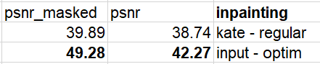  
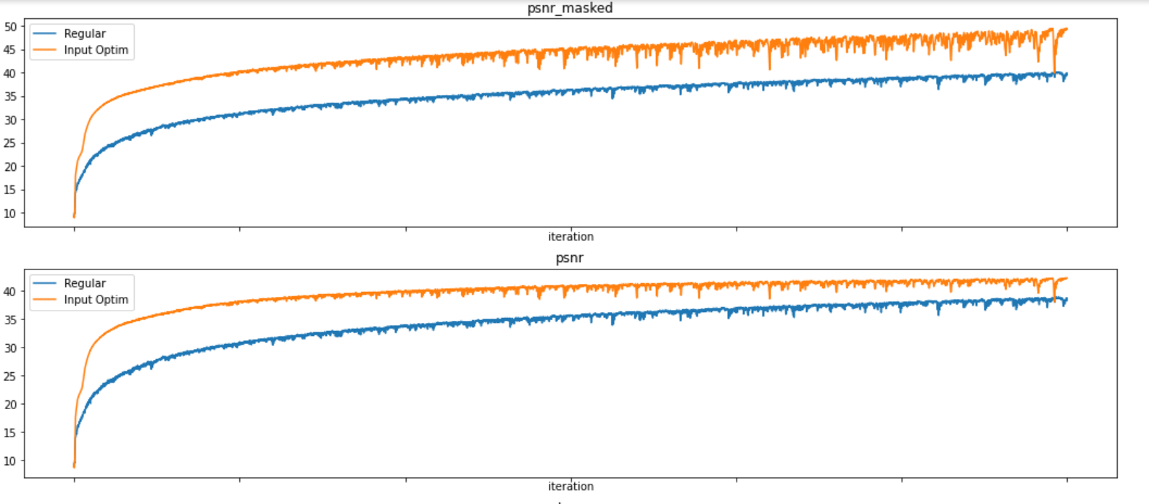  
Figure 8: **PSNR graphs of kate regular vs input optimization training.**In this figure, it is very clear that optimizing over the input has a big effect on the image quality and converging speed.

**Restoration  
barbara - negative example to input optim:  
   
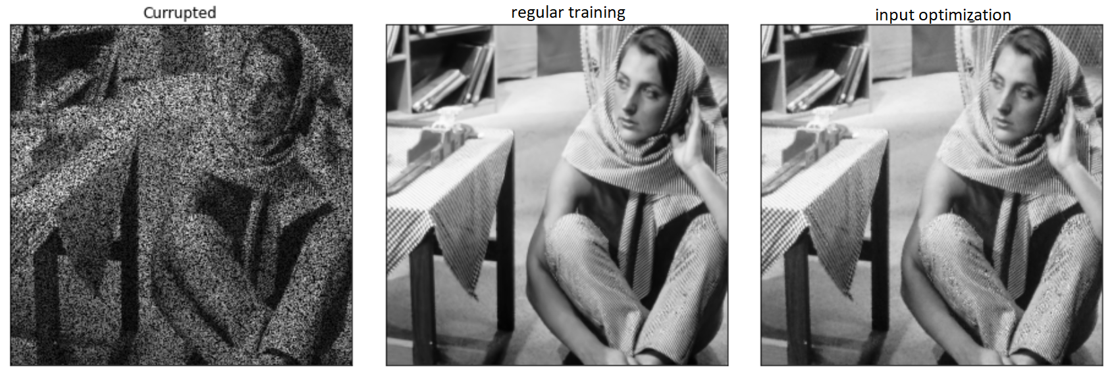**Figure 9: **Comparing regular training to input optimization of barbara image.**This is an example of an experiment where we got worse results when we optimized over the input. (the difference is noticeable on barbara`s pants)  
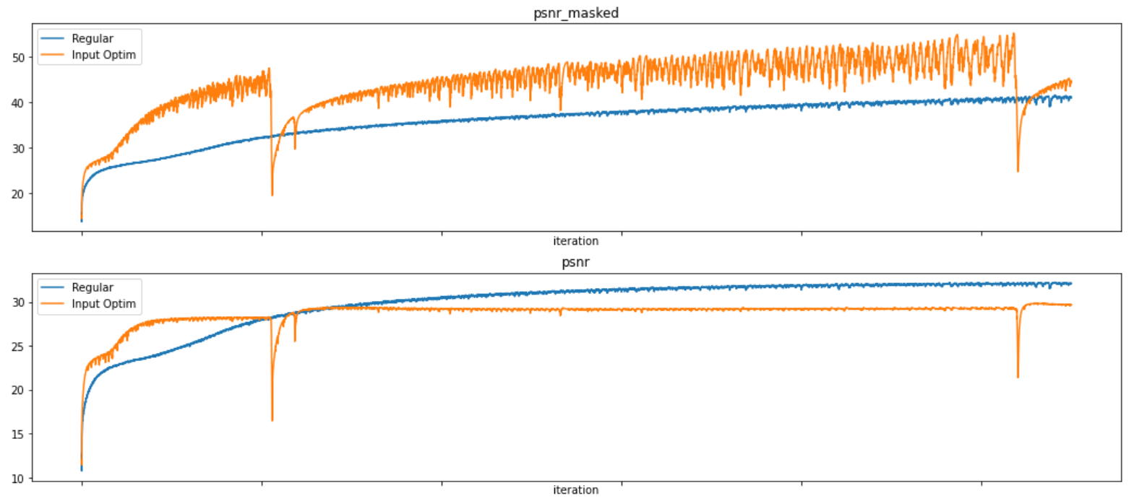  
Figure 10: **PSNR graphs of barbara regular vs input optimization training.**As we can see in figure 10, optimizing over the input got better results at psnr_masked, than at psnr.  
We think the problem occurred because the input optimization caused overfitting to the masked image, which resulted in worse results in terms of the psnr.

**Conclusions:** Optimizing over the input can improve the results of each application in terms of converging speed and quality, especially in case of inpaining or restoration.  
In some cases like denoising, input optimization will make our model to overfit to the noisy image, and therefore will result in worse looking outputs.

1. The third part of our experiments was to test adversarial training and compare it to regular/input optimization training.  
   We will show a number of experiments results which we think are important to examine our work.

**Vase (inpainting):**

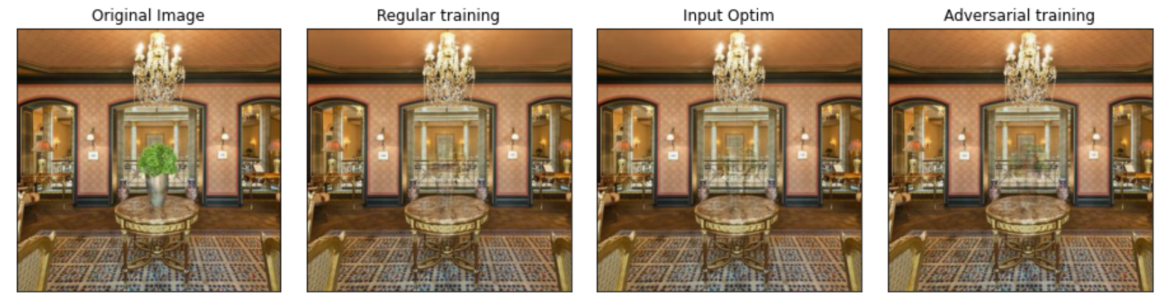  
Figure 11: **Comparing the results between all the training methods we tested.  
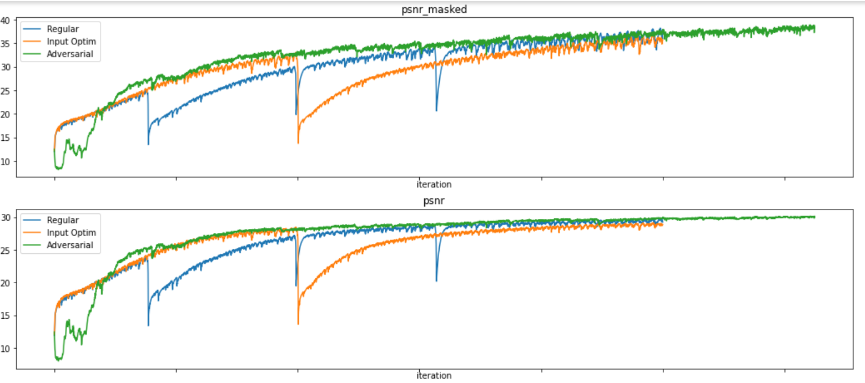**Figure 12: **PSNR graphs of all the training methods of vase inpainting image.**Some points we noticed in this experiment:  
1. Adversarial training achieved better results in terms of psnr and converging speed than others training methods.  
2. The completion of the vase looks best with input optimization method.  
3. Adversarial training captured fine details far from the vase better than other methods.(noticeable at the ceiling pattern)

**Kate (restoration):  
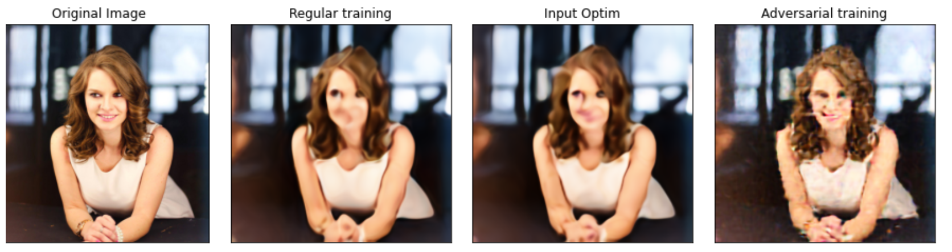**Figure 13: **Comparing the results between all the training methods we tested.  
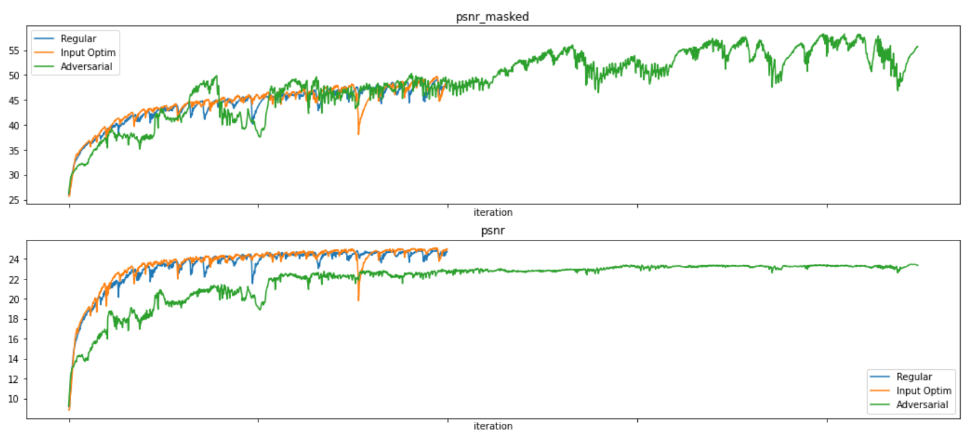**Figure 14: **PSNR graphs of all the training methods of kate restoration image.**Some points we noticed in this experiment:  
1. Adversarial training achieved worse results than the other methods did in terms of psnr and converging speed.  
2. Adversarial training was still able to reconstruct the kate image from only 2% of the original pixels.  
3. In terms of PSNR masked, adversarial training achieved better results than the other methods but worse result in terms of PSNR. We believe it happened because   
we overfitted to the masked image and the learning rate of the generator was too small to affect the parts that were masked.(HP tweaking experiments results will be presented next)

**Jet/Snail (Denoising) - negative example to adversarial training**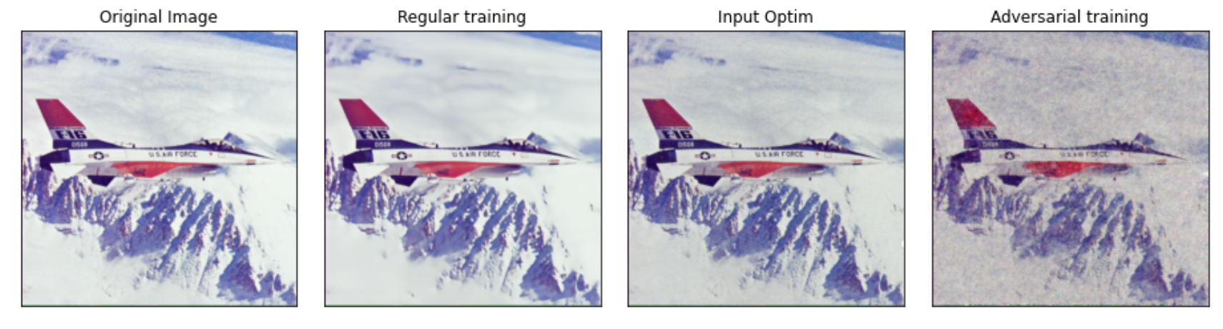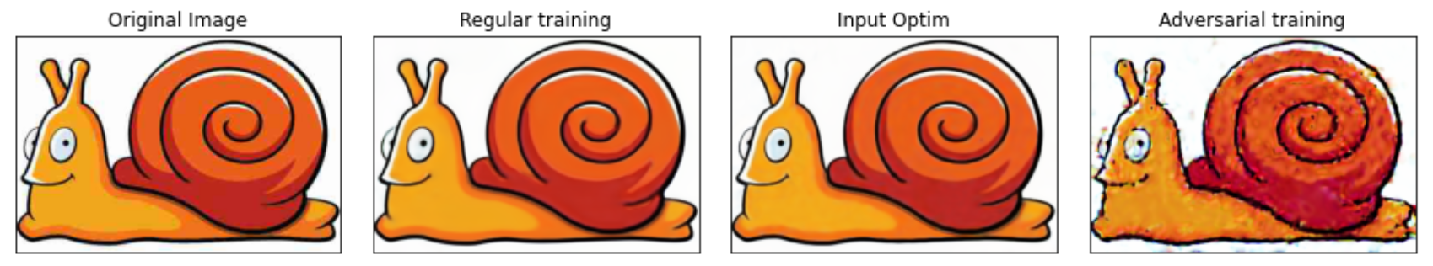  
Figure 15: **denoising final results comparison.**Top - removing normal noise from image, Bottom - removing jpeg compression noise.  
This is a good example to show where adversarial training might not fit.  
In both experiments in Figure 15, it is clear that adversarial training did a very poor job of removing the noise from the image.  
In the denoising application, we show that our network has high impedance to image noise, which means that while fitting we can filter the noise before overfitting to the image.  
In our case we believe the adversarial training overfit too fast to the noisy image, which makes it skip the part where the resulting image is noise free.

**Conclusions**: Adversarial training can achieve better results than regular training, especially in applications like small holes inpainting.  
In other cases like denoising, adversarial training is not recommended due to fast overfitting to the noisy image.  
We have noticed during our experiments that getting adversarial training to be stable training was a very hard job to accomplish, we had to tweak our HP tens times before finding good HP which makes the learning stable.  
Another important part we tested was different discriminator architectures, we found out that in order to get good results, we needed deep discriminator which resemble our generator downsampler part in terms of layer configuration. On the other hand we found out that too “strong” discriminators make training very hard and most of the time the model did not converge at all. (We do not have graphs or hard data about those experiments)

**Final PSNR results:  
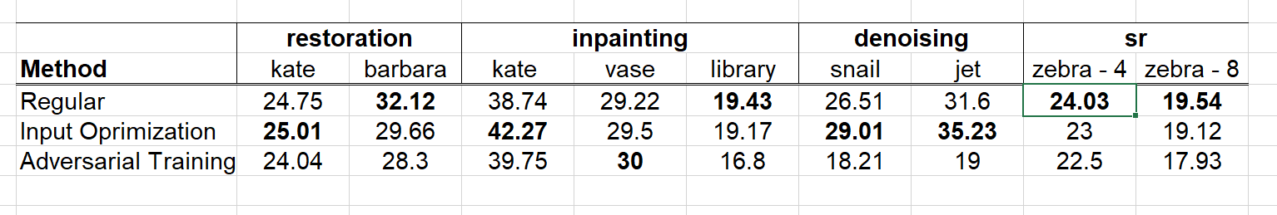**Table 1: **Final psnr results of all the application and image. We tested 3 methods of training and we marked which method got the best psnr results.**

**Complete results of all application (The ones we didn`t present):  
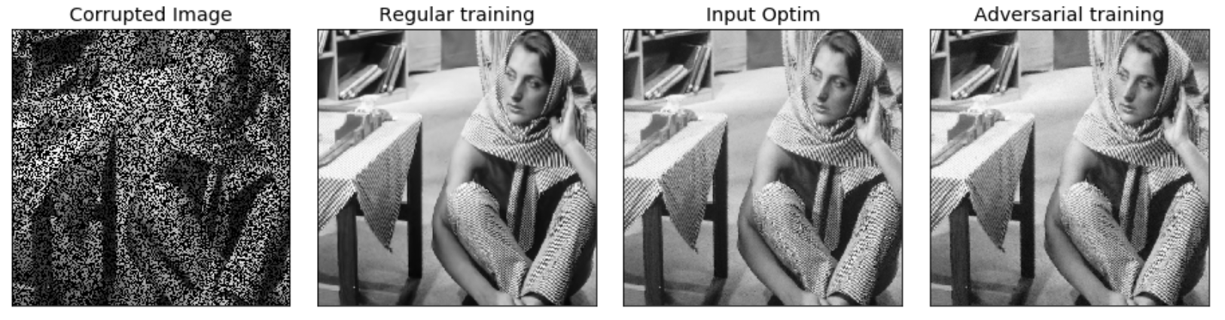  
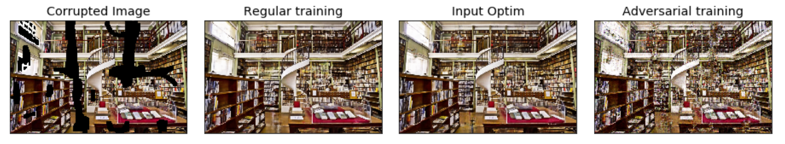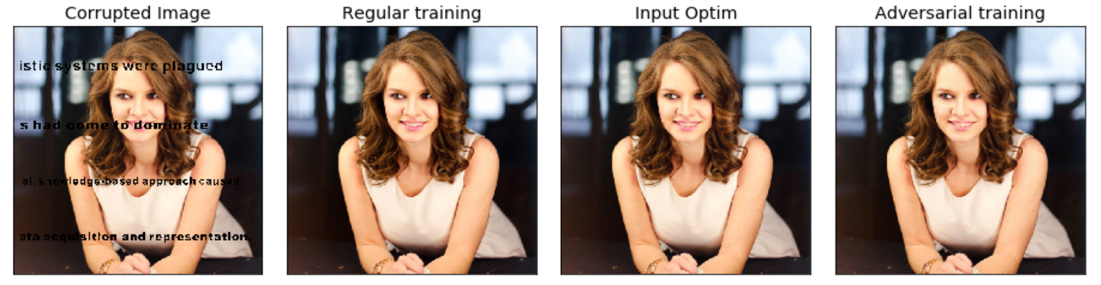  
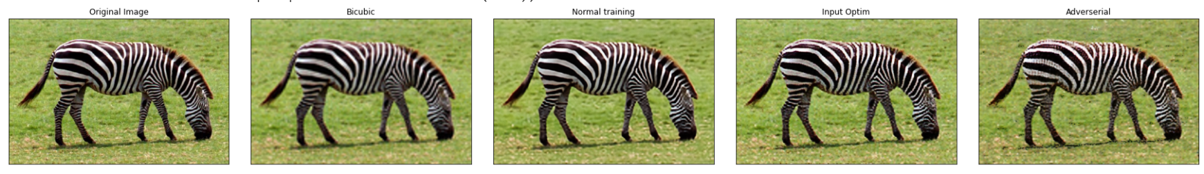  
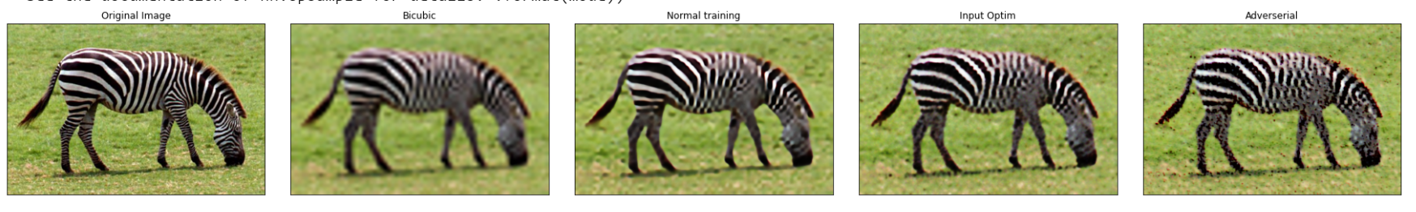**

**(Excel file ‘experiments_results’ describe some of the hp tweaking experiments and notes we did)**

1. Ulyanov, Dmitry, and Vedaldi, Andrea and Lempitsky, Victor. Deep Image Prior. 2017.